PROBLEM STATEMENT

|  |  |
| --- | --- |
| Date | 26 october 2023 |
| Team ID | NM2023TMID01019 |
| Project name | DRUG TRACEABILITY |
| Marks | 2 marks |

PROBLEM STATEMENT:

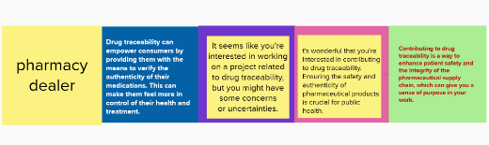

|  |  |  |  |  |  |
| --- | --- | --- | --- | --- | --- |
| **Ps-1** | Pharmacy  Dealer | Drug traceability can empower consumers by providing them with the means to verify the authenticity of their medications. This can make them feel more in control of their health and treatment. | It seems like you're interested in working on a project related to drug traceability, but you might have some concerns or uncertainties. | It's wonderful that you're interested in contributing to drug traceability. Ensuring the safety and authenticity of pharmaceutical products is crucial for public health. | Cntributing to drug traceability is a way to enhance patient safety and the integrity of the pharmaceutical supply chain, which can give you a sense of purpose in your work. |
|  |  |  |  |  |  |
|  |  |  |  |  |  |
|  |  |  |  |  |  |
|  |  |  |  |  |  |
|  |  |  |  |  |  |
|  |  |  |  |  |  |
|  |  |  |  |  |  |
|  |  |  |  |  |  |
|  |  |  |  |  |  |